Multiple-choice section

|  |  |  |  |  |  |  |  |  |  |
| --- | --- | --- | --- | --- | --- | --- | --- | --- | --- |
| Question | 1 | 2 | 3 | 4 | 5 | 6 | 7 | 8 | 9 |
| Answer | A | D | B | C | A | C | C | B | C |

Question 1 [6.1]

**A**

*w* is co-interior to *t*.

Question 2 [6.1]

**D**

Supplementary angles add to 180°.

180 – 65 = 115°

Question 3 [6.1]

**B**

*a =* 112° (vertically opposite)

*b =* 68° (co-interior)

*c =* 112° (corresponding)

Question 4 [6.2]

**C**

There are two sides and the included angle between the two pairs of equal sides. Therefore, the congruency test is SAS.

Question 5 [6.4]

**A**



Question 6 [6.1,6.3]

**C**

co-interior angles of parallel lines

180 – 82 = 98°

Question 7 [6.3]

**C**

Polygon angle sum is given by:   
*S* = 180(*n* – 2)

*S* = 180 (*n* – 2)

*S* = 180 x 3

*S* = 540°

Question 8 [6.5]

**B**



Question 9 [6.3]

**C**

Polygon angle sum is given by:

*S* = 180(*n* – 2)

Hexagon is *S* = 180 (*n* – 2)

*S* = 180 × 4

*S* = 720

*a* = 

*a* = 120°

Multiple-choice total marks: 9

Short answer section

Question 10 3 marks [6.2,6.5]

**(a)** Two congruent triangles are the same shape and the same size*.*

**(b)** Triangles that are the same shape but not the same size are similar**.**

Question 11 2 marks [6.1]

*e* and *f*  = 72° + 108° and are co-interior angles.

*b* and72° are *corresponding* angles.

*a* and *d* are *vertically opposite* angles.

*c* and *g* are *supplementary* angles*.*

*b and e are alternate* angles.

Question 12 6 marks [6.3]

|  |  |
| --- | --- |
| **(a)** Triangle  *x* + 90 + 51 = 180  *x* + 141 = 180  *x* = 180 – 141  *x* = 39° | **(b)** Trapezium  2*m* + 109 + 78 + 43 = 360  2*m* + 230 = 360  2*m* = 130  *m* = 65° |

|  |  |
| --- | --- |
| **(c)** Quadrilateral  *x* + *x* + 2*x* + 110° = 360°  (sum of angles of a quadrilateral is 360°)  5*x* = 360° – 110°  5*x* = 250°    *x* = 50° | **(d)** Parallelogram  6*a* + 4*a* = 180°  (co-interior angles in parallel lines add up to 180°)  10*a* = 180°  *a* = 18°  *b* = 4*a*°  (opposite angles of a parallelogram are equal)  *b* = 4 × 18  *b* = 72° |

Question 13 3 marks [6.5]

∠*ACB* = 10° (angle sum of triangle)

∠*EDF* = 20° (angle sum of triangle)

In ∆*ABC* and ∆*DEF*

∠*ABC* = ∠*DEF* (both 110°)

∠*ACB* = ∠*DFE* (both 10°)

∠*BAC* = ∠*EDF* (both 20°)

∴ ∆*ABC* ~ ∆*DEF* (AAA)

Question 14 2 marks [6.2]

The hypotenuse in each triangle is 16 cm. Each triangle has another side equal to 14 cm.

Each triangle has a right angle. The triangles are congruent using the RHS test.

Question 15 2 marks [6.7]

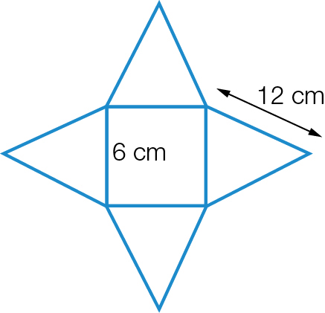

Question 16 2 marks [6.6]

The triangles are similar because they each have a right angle and a pair of vertically opposite angles that are equal.



Question 17 3 marks [6.4]

side of small rectangle = 2 cm

side of large rectangle = 4 cm

scale factor = 4 ÷ 2 = 2

Question 18 3 marks [6.1]

5*e* + 3*e* + 60° = 180° (angle sum of triangle is 180°)

8*e* + 60° = 180°

8*e* = 120°

*e* = 15°

*d* = 5*e* (alternate angles in parallel lines)

*d* = 5 × 15° = 75°

*f* = 120°

Question 19 3 marks [6.2]

In ∆*ABC* and ∆*FEC*

∠*ABC* = ∠ *FEC* (alternate angles, *AB* || *EF*)

∠*BCA* = ∠*ECF* (vertically opposite angles)

*AB* = *EF* (15cm, given)

∴ ∆*ABC* ≡ ∆*FEC* (AAS)

∴ *x* = 7 (matching sides of congruent triangles)

Short answer total marks: 30

Extended answer section

Question 20 9 marks [6.3]

**(a)** parallelogram

**(b)** *AB* and *DC*, *BC* and *AD*

**(c)** ∠*DAB* and **∠***BCD*, **∠***ADC* and **∠***ABC*

**(d)** *BD*

**(e)** ∆*ABC* and ∆*ADC*

**(f)** They are congruent. Test could be SSS or SAS.

Question 21 8 marks [6.6]

In *EFG* and *HIG*

∠*EFG* = ∠*HIG* = 90° (given)

∠*EGF* = ∠*HGI* (given)

∠*GEF* = ∠*GHI* (angle sum of triangle)

∴*EFG* ~ *HIG* (AAA)



Question 22 4 marks [6.6]

∆*ABC* is similar to ∆*DEC* (AAA)

*CE* = 2.8 – 0.8 = 2 m





Question 23 3 marks [6.7]

*F*= 5 *F + V –* 2*= E*

*V*= 6 5 + 6 *–* 2= 9

*E*= 9 9 = 9

Question 24

(a) 3 marks [6.6]

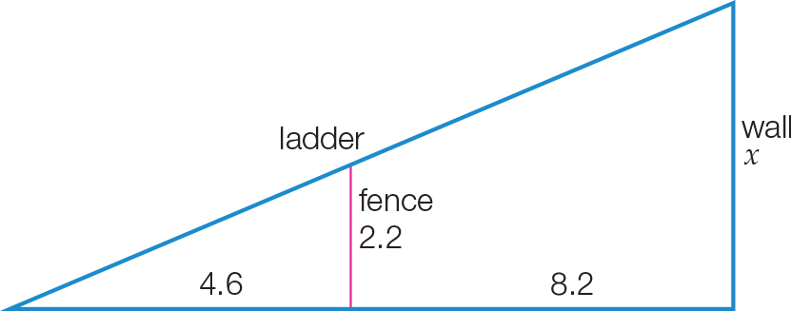

**(b)**



Extended answer total marks: 27

TOTAL test marks: 66